**Experimental setup for screening with Non-redundant Cross-validation (NRCV) or Screening SuperDRUG2**

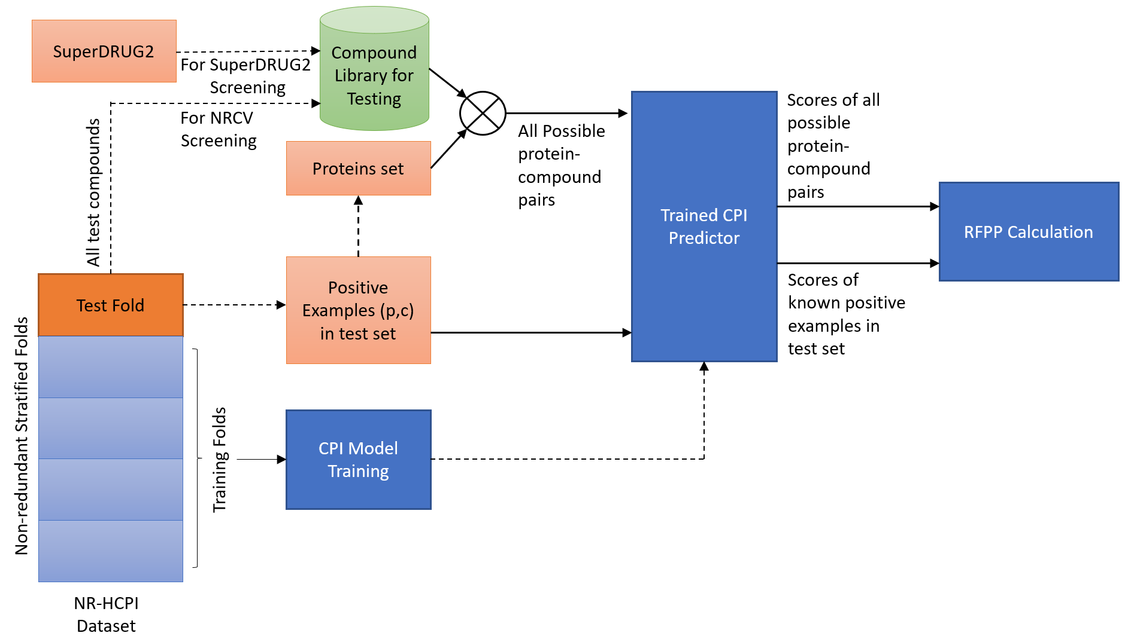

Figure 1 shows the setup of screening experiments used for RFPP calculation.